Usability Testing Report: Task Cycle (Mini Cycle) Web Application

# 1. Introduction

The primary objective of this report is to thoroughly evaluate the usability, functionality, and user experience (UX) of the "Task Cycle (mini cycle)" web application. The testing focuses on its core feature—the cyclical management of repeatable tasks—and its effectiveness for a target audience of non-technical users. This analysis aims to confirm the proper functioning of all features outlined by the client, identify any potential usability issues, and assess the overall clarity and efficiency of the application's design.

# 2. Methodology

A complete navigation and functional test of the "Task Cycle (mini cycle)" web app was performed. The evaluation encompassed a series of predefined tests to verify key features and user flows. The methodology involved:

• Functional Verification: Creating new task lists, adding tasks, and managing them to ensure all core features work as intended.

• Cycling Task Workflow: Performing a full cycle of tasks under both "Auto Reset" and "Manual Complete" settings to confirm the core functionality, including the "Delete Checked Tasks on Complete" setting.

• Feature-Specific Testing: Verifying functionality of due dates, the Undo button, the Stats Panel, and the Recur Task option.

• Navigation and UI Assessment: Evaluating the ease of switching between task lists and navigating the app.

• Target User Alignment: Assessing intuitiveness for non-technical users, as intended by the client.

# 3. Findings and Results

This section outlines the specific usability issues identified during the testing process, analyzes their potential impact on user experience, and provides detailed recommendations for improvement.

#### Scenario 1: First Impression and Theme Customization

* **Test Steps**:
  + Open the Task Cycle (mini cycle) web application.
  + Observe the initial view and overall aesthetic.
  + Switch to "dark theme."
* **Findings**:
  + The initial view of the application presents a clean and straightforward interface, aligning with its intended simplicity.
  + Upon switching to the "dark theme," it was observed that the title text on the home page becomes difficult to read due to insufficient contrast between the dark background and the dark color of the title text.
* **Recommendation**: For the "dark theme" and any other dark-toned themes, the color of the title text should be changed to white (or a light color) to ensure adequate readability and accessibility.

#### Scenario 2: Creating and Populating Task Lists

* **Test Steps**:
  + Locate the "+ Create New" option in the menu.
  + Create two new mini-cycle task lists, naming them appropriately (e.g., "Morning Routine" and "Night Routine").
  + For each list, add a few relevant tasks using the provided input method.
  + Verify that the tasks are displayed correctly within each list.
* **Findings**:
  + The "+ Create New" option was easily found in the menu. However, the wording could be more specific. The app's core function is about creating a cycle of tasks, not just a generic "new" item.
  + Creating new task lists was a simple and intuitive process.
  + Adding tasks to each list was straightforward, and the tasks were displayed correctly.
* **Recommendation**: To reduce ambiguity and better communicate the app's purpose, the menu option should be changed from "+ Create New" to "+ Create New Cycle." This change would clearly and correctly indicate the intended action to the user from the very beginning.

#### Scenario 3: Completing a Cycle with Auto Reset

* **Test Steps**:
  + Open one of the created task lists.
  + Check off all the tasks in the list to simulate completion.
  + Observe whether the list automatically resets for the next cycle.
  + Repeat this cycle a few times to ensure the auto-reset functionality is consistent throughout different cycles and tasks.
* **Findings**:
  + The process of checking off tasks was clear and responsive.
  + **Critical**: The "Auto Reset" feature did not consistently reset the task list after all tasks were completed. During testing, an issue was encountered twice. Despite all tasks being checked off, the list remained in the completed state and did not automatically reset, contradicting the intended functionality. (A screen recording has been attached to the report to highlight the issue.)
* **Recommendation**: This is a critical bug that affects the application's core functionality. It is recommended that the issue be investigated immediately. The conditions under which the automatic reset fails to trigger need to be identified and fixed to ensure a reliable and consistent user experience.

#### Scenario 4: Completing a Cycle with Manual Reset (Auto Reset Off)

* **Test Steps**:
  + Navigate to the menu and turn OFF the "Auto Reset" option.
  + Open one of the task lists.
  + Check off all the tasks in the list.
  + Look for and interact with the "Complete" button to finish the cycle manually.
  + Observe if the list resets after pressing the "Complete" button.
  + Checked the delete task upon completion switch and observed if it's functional.
* **Findings**:
  + The option to turn off "Auto Reset" was easily accessible in the menu.
  + After checking off all tasks, the list remained in a completed state until the "Complete" button was pressed.
  + Upon pressing the "Complete" button, the task list reset, demonstrating the correct functionality of the manual reset option.
  + As for the delete tasks upon completion, we were able to select one task or more then click on complete to have the selected tasks deleted from the cycle.

#### Scenario 5: Setting and Displaying Due Dates

* **Test Steps**:
  + Open one of the created task lists (e.g., "Morning routine").
  + Locate the area associated with a task (e.g., "Wash my face") where a due date can be set.
  + Interact with the due date input field and set a date (e.g., 21/08/2025).
  + Verify that the due date is displayed next to the task.
* **Findings**:
  + The option to set a due date for a task is shown directly when pressing the task and then displayed below the task’s description, within a clearly defined input field. This placement makes it relatively easy to find.
  + The set due date is displayed directly below the task description, providing clear visibility.
* **UI/UX Recommendation**: While the current implementation is functional, the visual prominence of the due date could be improved. Consider the following UI/UX enhancements:
  + **Visual Cue**: Add a small calendar icon next to the due date to further reinforce its purpose.
  + **State-Based Styling**: If a due date is approaching or has passed, consider applying subtle visual cues (e.g., changing the text color to orange or red) to draw the user's attention and help prioritize tasks. This would enhance the at-a-glance understanding of task deadlines.
  + **Interaction Feedback**: When the due date is set, provide clear visual feedback to confirm the action (e.g., a subtle animation or a change in the input field's appearance).

#### Scenario 6: Switching Between Task Lists

* **Test Steps**:
  + Open one of the created task lists (e.g., "Morning routine").
  + Open the main menu and select the "Open" option.
  + Observe the interface for switching between lists.
  + Choose another task list (e.g., "Night routine") from the available options.
  + Verify that the application successfully switches to the selected task list.
  + Repeat the process to switch back to the first list.
* **Findings**:
  + The "Open" option in the menu successfully brings up a modal to manage and switch between different task lists.
  + The current wording "Open" is ambiguous. It could mean "open a file," "open settings," or something else entirely. The user must infer its purpose from the context of the modal that appears.
  + When a list is selected, a small preview pane shows the tasks within it. This preview pane is a fixed, small size and is not resizable. For lists with many tasks, this preview is impractical, as it requires scrolling, which defeats the purpose of a quick at-a-glance preview.
* **Recommendation**:
  + **Change Wording**: The menu option should be more descriptive to indicate its function. A name like "Switch Cycle," "Open Cycle," or "Manage Cycles" would provide clearer context for non-technical users and align better with the app's core concept.
  + **Resizable Preview**: The preview text area in the "Open Mini Cycle" modal should be made resizable. This would allow users to expand the view to see all tasks in a long list without having to open the cycle and then switch back. Alternatively, the preview could be designed as a scrollable container that automatically expands to a larger, but still constrained, height to better display the list.

#### Scenario 7: Using the Stats Panel

* **Test Steps**:
  + Open one of the task lists and complete a few tasks.
  + Locate the method to access the Stats Panel (swipe left on mobile or use the arrow button on computer).
  + Open the Stats Panel.
  + Confirm that the stats displayed (e.g., tasks completed, cycles completed) are accurate based on the actions performed.
* **Findings**:
  + The Stats Panel was easily accessible via both a swipe gesture and the arrow button.
  + The stats displayed on the panel accurately reflected the number of tasks completed during the testing session.
  + The stats incremented according to each completed cycle.

#### Scenario 8: Utilizing the Undo Button

* **Test Steps**:
  + Open a task list and check off a task as completed.
  + Immediately locate and click the "Undo" button (top left-hand corner).
  + Verify that the task is marked as incomplete again.
* **Findings**:
  + The "Undo" button was clearly located in the top left-hand corner.
  + Clicking the "Undo" button successfully reversed the action of completing a task, marking it as incomplete again.
  + The undo button also reversed the editing of tasks and all kinds of modifications done.

#### Scenario 9: Managing Recurring Tasks

* **Test Steps**:
  + Ensure "Auto Reset" is turned OFF and "Delete Checked Tasks on Complete" is enabled.
  + Open a task list and locate the "Recur Task" option for a few tasks.
  + Enable recurring for these tasks, setting a recurrence schedule (if prompted, or note the default behavior).
  + Check off the recurring tasks as completed.
  + Observe that the tasks are deleted upon completion.
  + Wait for a short period and verify that the recurring tasks reappear in the list.
* **Findings**:
  + The "Recur Task" option was available for individual tasks.
  + After enabling recurring for tasks and marking them as complete, they were immediately deleted from the list, as expected with the "Delete Checked Tasks on Complete" setting enabled.
  + The recurring tasks reappeared in the list after a short delay, indicating that the recurring functionality is working correctly.

### Screenshots:

##### Scenario 1: Themes

##### 

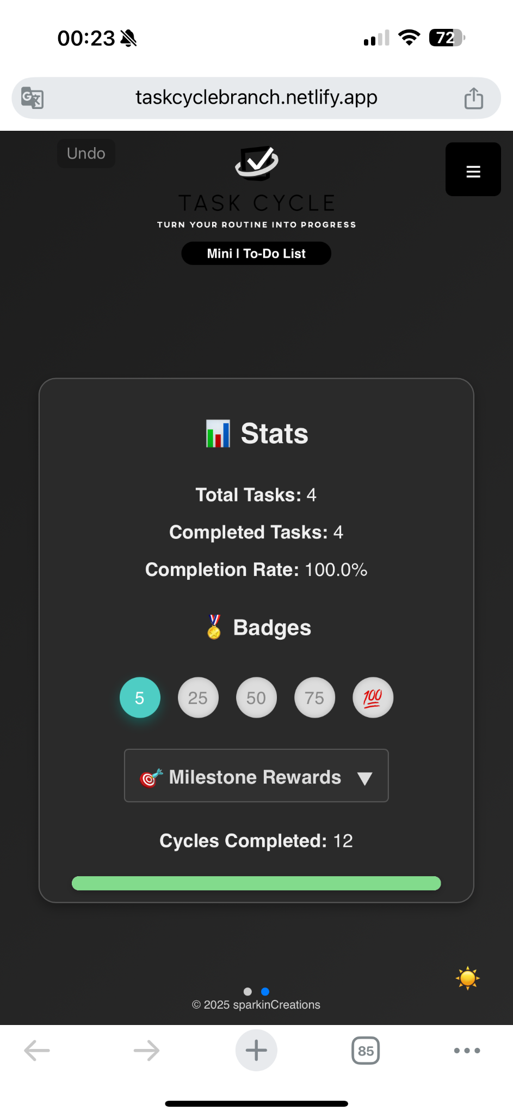

##### Scenario 2: Create a New Task Cycle

### 

### 

* Scenario 3: Auto-completion

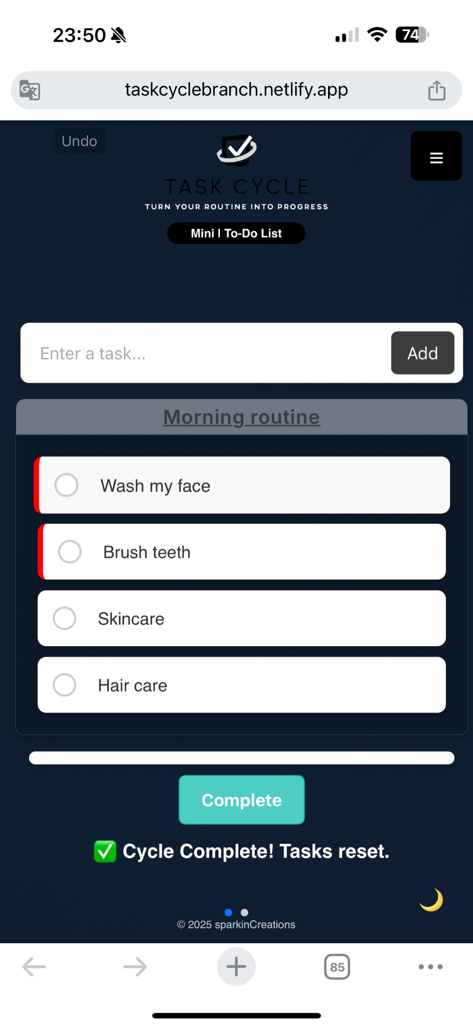

### Critical issue :

* Scenario 4: Completing a Cycle with Manual Reset (Auto Reset Off)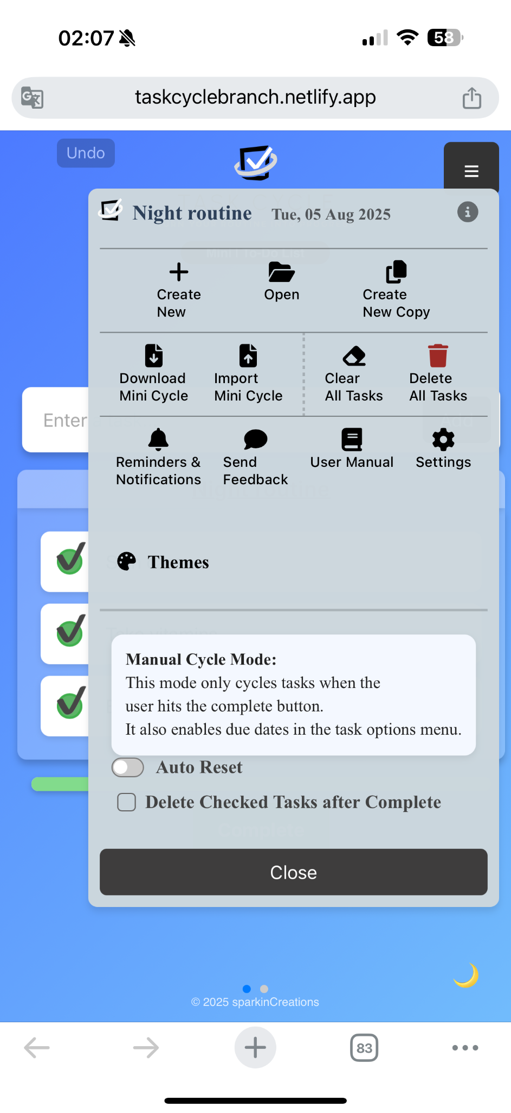

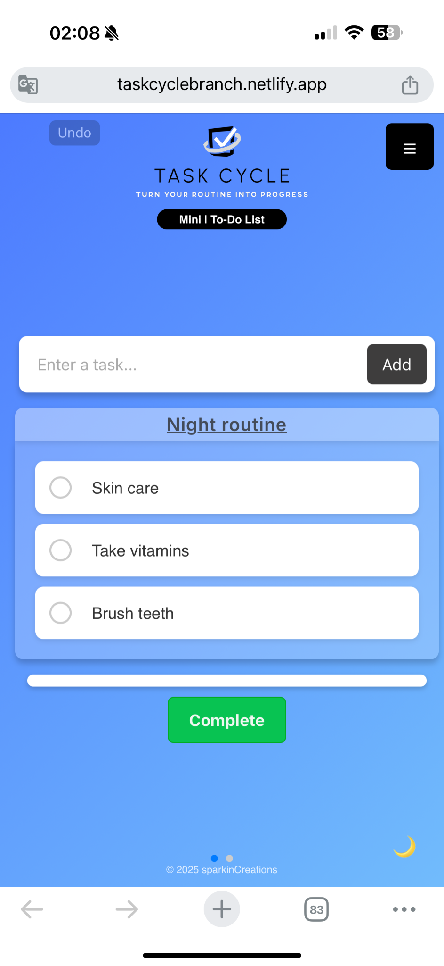

* **Scenario 5: Due dates**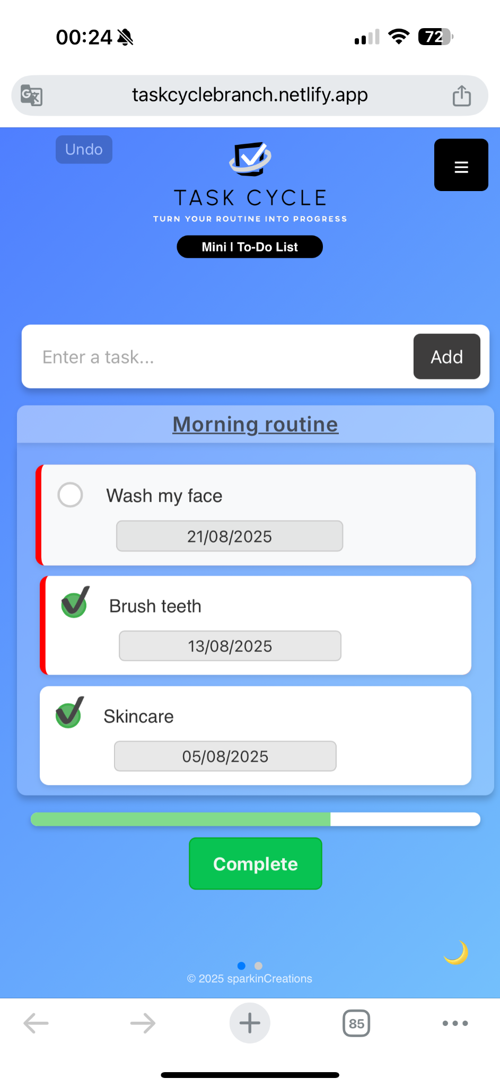

#### Scenario 6: Switching Between Task Lists

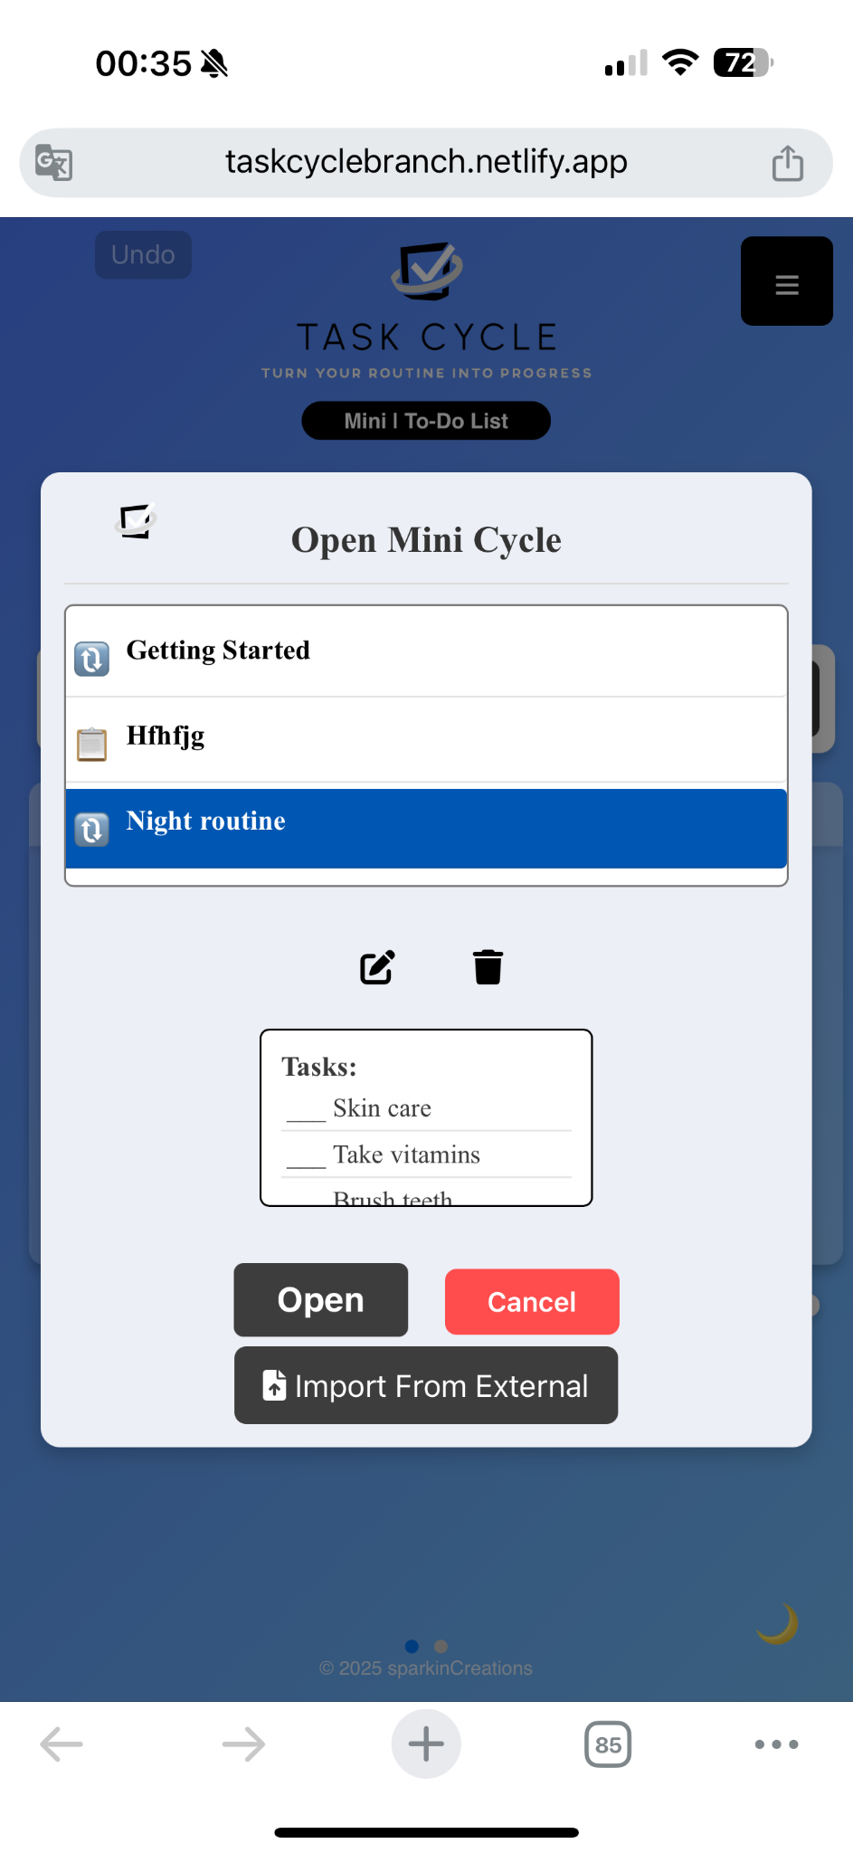

#### Scenario 7: Using the Stats Panel

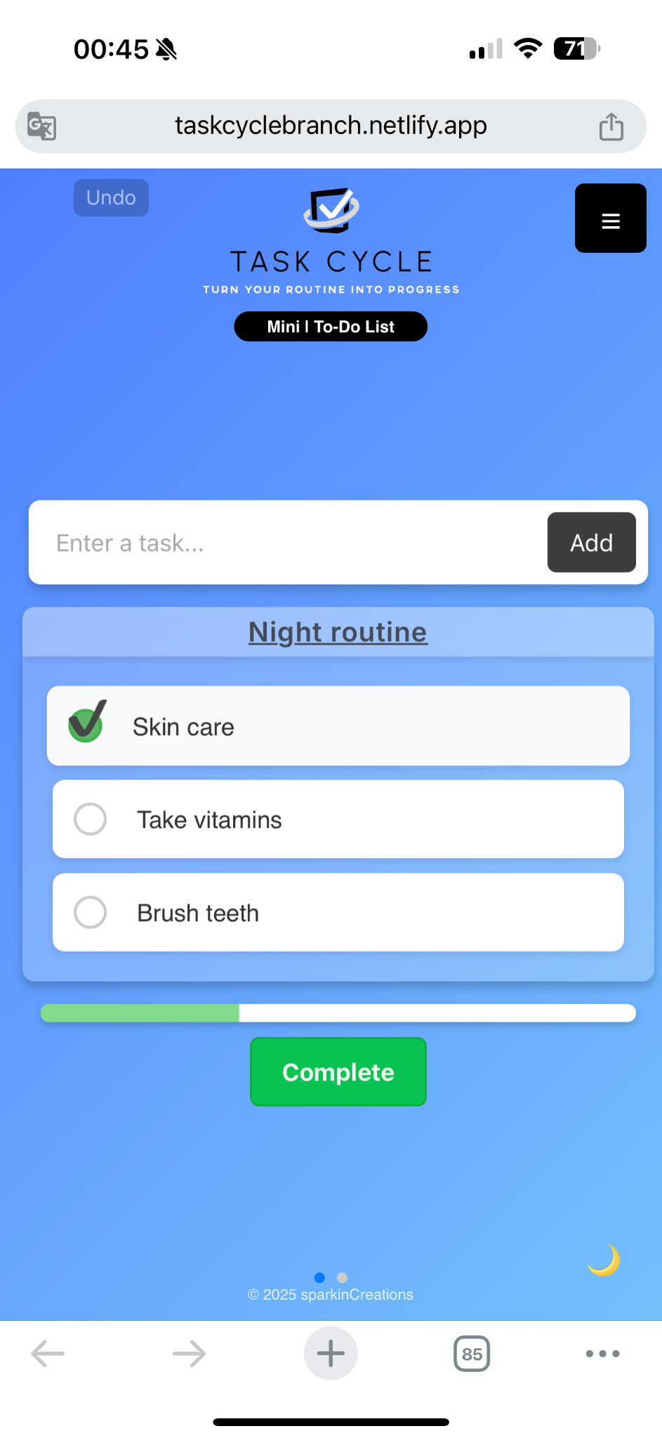

### 

### 

### 

### 

### 

### 

### 

### 

### 

### 

### 

### 

### Conclusion and Overall Assessment

The "Task Cycle (mini cycle)" application successfully implements its core concept of providing a simple, repeatable task management system. The design is clean and generally intuitive, making it well-suited for its target audience of non-technical users. The key features—creating lists, manual and automatic cycling, and recurring tasks—are all functionally present.

However, the testing process identified several key areas for improvement:

1. **Critical Functionality Bug**: The "Auto Reset" feature, which is central to the app's value, is not consistently reliable. This bug must be prioritized and fixed immediately to prevent user frustration and ensure the app delivers on its core promise.
2. **Clarity and Ambiguity**: The current menu language ("Create New," "Open") is too generic and could confuse new users. Changing these labels to more descriptive, cycle-specific terminology ("Create New Cycle," "Switch Cycles") would significantly improve the user's understanding of the app's features from the outset.
3. **Visual and Interactive Design**: While functional, elements like the due date display and the list preview pane lack polish. Implementing visual cues, state-based styling, and a resizable preview would enhance the overall user experience and make task management more efficient.

Overall, the application has a solid foundation. Addressing the critical bug and refining the user interface and terminology will elevate it from a functional prototype to a robust and highly usable application. Further testing on a wider range of devices and with a larger group of non-technical users is recommended to uncover additional usability insights.